Email Marketing with Announcer Pro

Overview

Contents
Messaging 2
Quick Pitch 2
Top-line Benefits 2
Supporting Statistics 2
Detailed Benefits 2
Features 4
Feature Overview 4
Customer Experience 6
Sales Support 12
Probing Questions 12
Selling Points 12
Objection Handlers 13
Frequently Asked Questions 14

Messaging

Quick Pitch
Are your customers looking for a way to engage with existing customers and keep them coming back?
Announcer Pro makes it easy for businesses to create and send professional email newsletters to their customers. Create one or many campaigns that can be sent to targeted customers at different times.
Send a monthly company newsletter, or tip of the week; promote a seasonal sale or new product line up. It gives their customers a reason to keep the company, products, and services top-of-mind.

Top-line Benefits
- Look Professional: Easily create and send professional email newsletters to customers. Choose from hundreds of email templates that include suggested text and titles.
- Ease of Use: Customize email marketing with a simple drag-and-drop editor.
- Stay Connected: Create engaging customer communications to stay top of mind even after a purchase.
- Improve Marketing: Measure and improve email marketing campaign performance with detailed reporting, including open and click rates and social media activity so that the right customers are targeted with the right message at the right time.

Supporting Statistics
- Personalization boosts engagement. Personalized subject lines make recipients 50% more likely to open the email. (Zero Bounce, 2023)
- Email Marketing informs customer buying behavior. 50% of people buy from marketing emails at least once per month. (Salecycle, 2022)
- Email Marketing has a great ROI. Email generates $36 for every $1 spent. (Snov.io, 2023)

Detailed Benefits
No Expertise Required | - Once customers have an active email list of customers, they are ready to send their first newsletter in a few simple steps;  - Choose a template or layout, add content, and click send—anyone can send powerful email marketing campaigns.  - Useful, pre-populated templates for the business-type, from newsletters to coupons and event invites, even holiday themed layouts.  - Preview the designs, send test emails, and perform SPAM checks to ensure emails meet best practices.  - Once ready, send the email. Customers that have opted-in will receive emails.
Stay Top-of-Mind | - Easily manage multiple campaigns.  - Businesses can pre-schedule specific dates and times to send emails whether they are in or out of the office.  - Create auto-response emails for customers who subscribe.
Social Integration | - Increase visibility of marketing campaigns by integrating Twitter and Facebook share buttons.  - Share emails directly to Facebook or Twitter accounts.
Build a send list | - Add a sign-up form to the website to increase the mailing list size and stay top-of-mind with more customers.  - Import contacts from Outlook, Yahoo or Gmail, or upload list files.  - Segment the contact list for targeted messaging.
Campaign Reporting | - Measure the effectiveness of campaigns with detailed reporting on:  - Total emails sent and opened  - Bounces, clicks and unsubscribes  - Social media activity  - Download detailed reports in HTML, CSV or PDF formats.
Cost Effective | - Announcer Pro is a cost effective and easy to use solution that allows customers to create email campaigns without extra features they don’t need.

Features

Feature Overview
Professionally Designed Newsletter Templates | - A wide variety of templates. Choose from over 300 pre-built newsletter templates that include suggested text and titles.  - A layout for different newsletter types. Traditional newsletter style, coupon/special offer and special announcement.  - Business owners can easily add their own content using drag and drop functionality. Upload their logo, add text, links and social media.  - Simple drag and drop editing, for example:  - Adding block(s): Allows additional customization to the email.  - Modifying Font Style, Colors, and Text Size: Customers can double-click on the text block they wish to modify. Highlight the text they wish to reformat, click on the font change button. A screen will pop up allowing them to Select Font Style, Font Colors and Font Size.  - Insert and Edit Images: Business owners can build their own library of images by uploading the image files; and/or utilize the free image library to place additional images into the email.  - Create/Edit link and Remove link: Customers can highlight the text they wish to link from. Click on the hyperlink icon. A screen will pop up.  - Preview: Preview all the changes made.  - Send Test: Send email tests prior to sending an email to contacts.  - Business owners can add their own images or choose from a library of 30,000+ free images.  - Personalize the newsletters. Properly address customers by adding first and/or last name.
Schedule Multiple Campaigns | - Easily manage multiple campaigns. Business owners can pre-schedule specific dates and times to send individual newsletters whether they are in or out of the office.  - Unlimited number of newsletters. Unlike other email marketing services, users can send as many newsletters as they want without worrying about restrictions or additional costs.
Contact Management | - Easily build a contact list. Create individual contacts or upload existing contacts in excel.  - “Lists”, “Add Contacts”, “Search Contacts”, “Import/Export Lists” and “Merge Lists”.  - Import contacts from Outlook, Yahoo! Mail or Gmail or LinkedIn.  - Import Contacts from files on a computer.  - Organize the contact list. Add, edit or delete individual contacts with easy-to-use management tools.
Social Media | - Increase visibility of campaigns. Integrate Twitter and Facebook share buttons.  - Share emails to social media directly through the “Social Networking” tab.
Campaign Reporting | - Measure the effectiveness of a campaign. View detailed reporting on:  - Total emails sent and opened  - Clicks, bounces and unsubscribes  - Social media activity (Twitter or Facebook share clicks)  - View email performance as list, percentages, and visual breakdowns.  - View and download up-to-date reports in PDF, HTML or CSV format.  - Compare the performance of sent campaigns.
Abuse Management | - Respect opt-in and unsubscribe laws.  - Automatic duplicate email address verifier.  - Measures in place so that emails are more likely to be delivered directly into the recipients’ inbox instead of a spam folder.

Customer Experience
Click “Launch Application” to start using Announcer Pro, the application will open in a new window.
When a customer clicks on “Start” the following page is loaded.

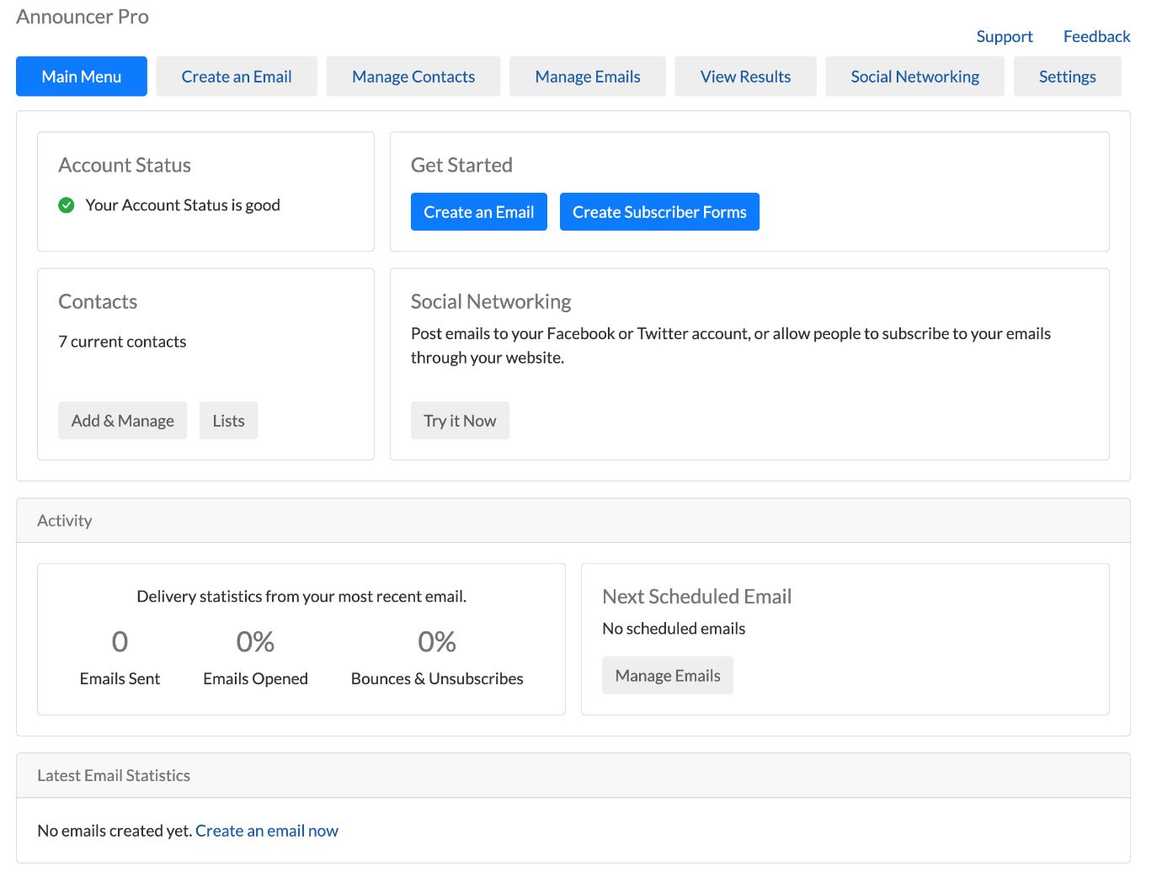

There are 5 easy steps to getting started with a new email campaign.
Step One: Start by creating a new email. Previously-registered information will be populated for the customer. They will need to confirm or edit per email campaign.
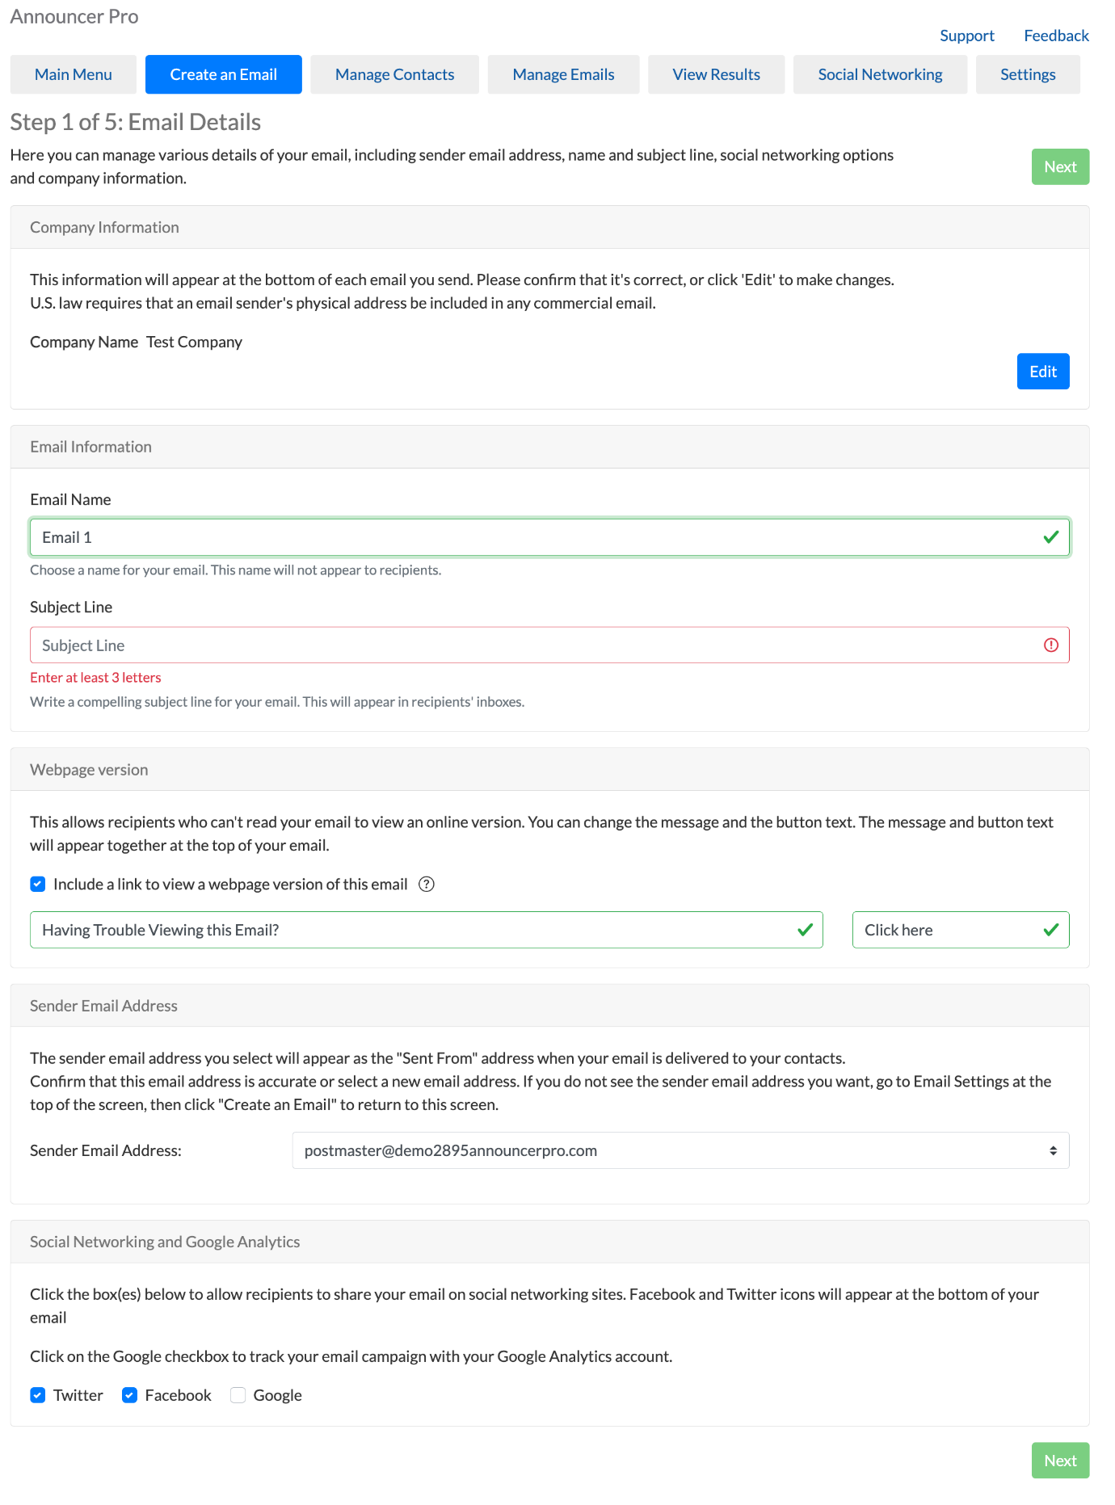
Step two: Choose contacts. Choose existing or add new contacts.

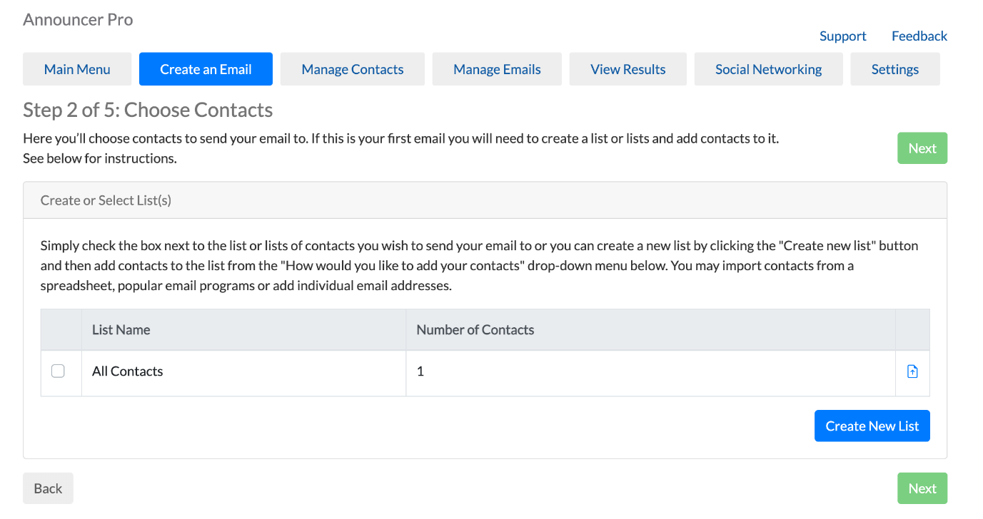

Step three: Choose a template. Templates allow customers to select the overall layout and theme of the newsletter.

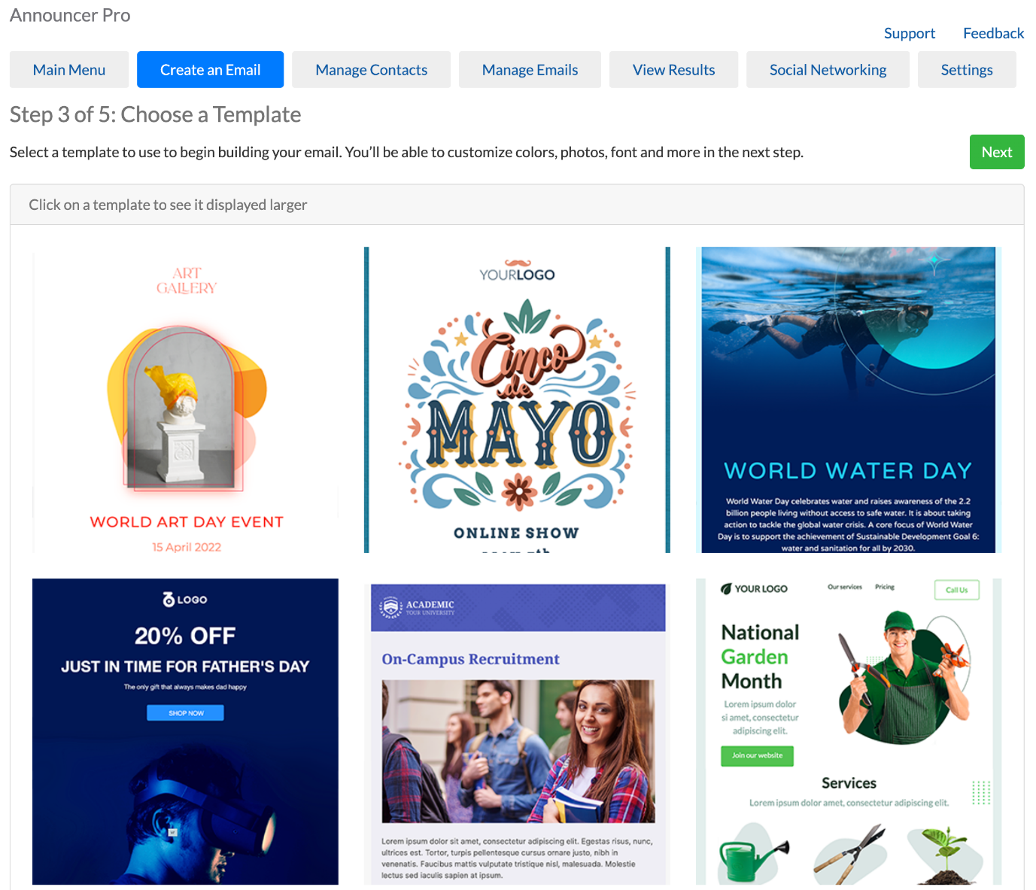

Step four: Edit template. Customers can modify a newsletter by clicking, dragging and highlighting different aspects of the newsletter. Note that some default layout and images are locked and cannot be deleted.

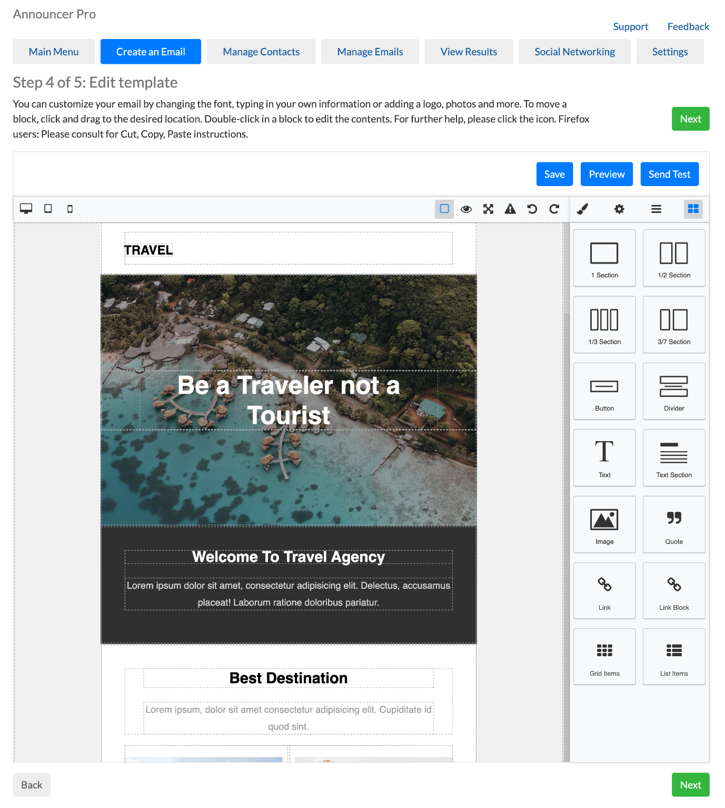
Any newsletters which customers have not finished can be returned to and edited at a later date.
Step five: The next step is to Preview the email and send a test before sending or scheduling.

Once the customer is happy with the email, they’re ready to send or schedule it.
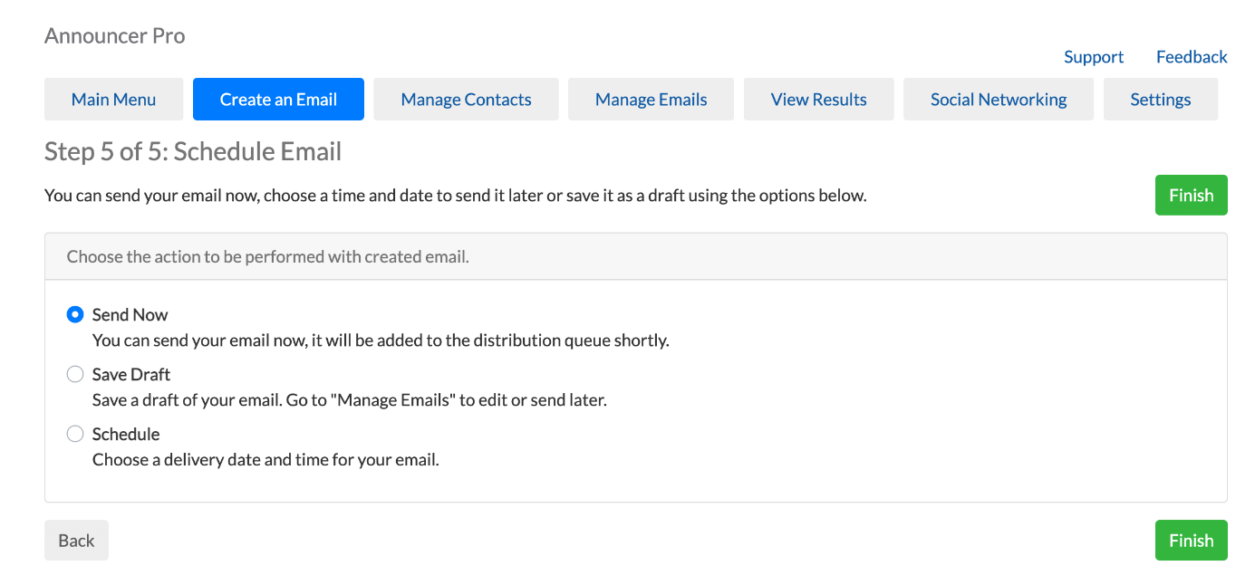

And that’s it!

Customers can see how their email performed through the View Results page. They can get detailed reporting on the send, open and click rates, and download reports in HTML, CSV or PDF files.
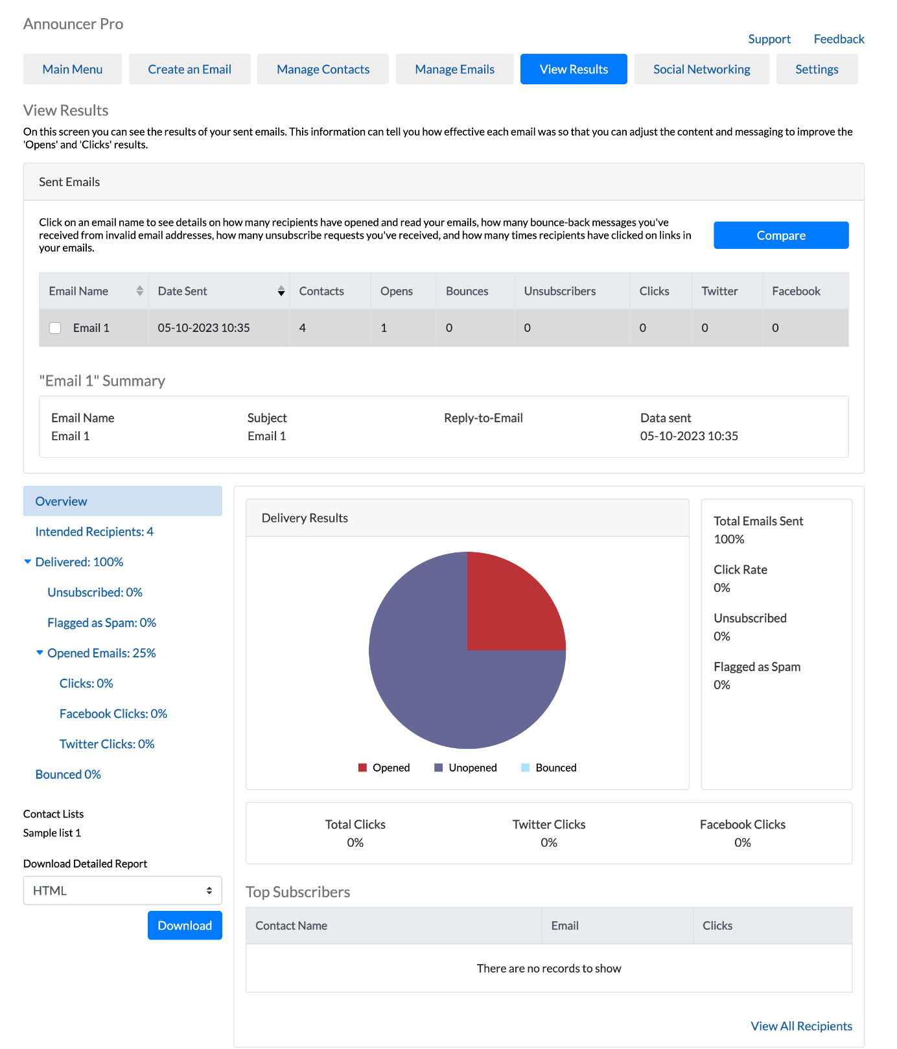

Under Manage Contacts, users can create individual contacts, upload or import contact lists, create a subscriber form for the website and more.
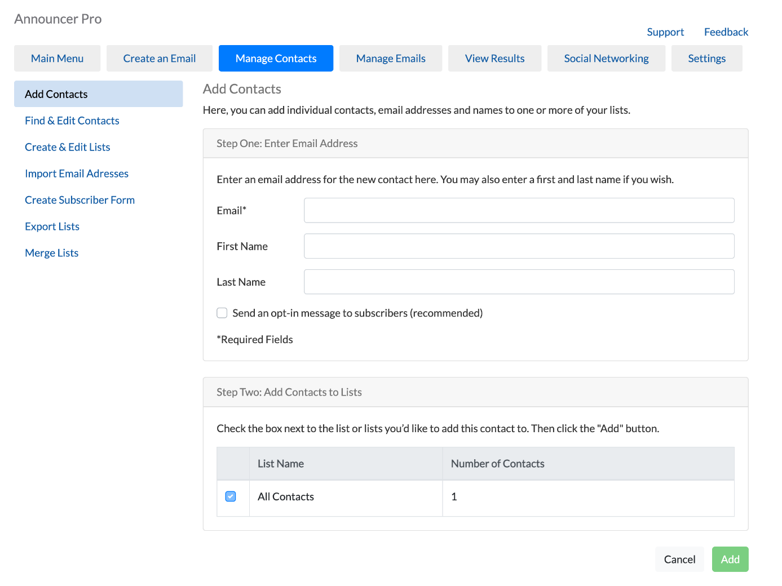

Sales Support

Probing Questions
How are you advertising your business?
- Email marketing is one of the most effective, cost-efficient ways for small businesses to advertise and stay top of mind with customers. Stats show that email marketing was ranked as the best channel in terms of return on investment for digital marketing.
- What’s your budget?
- What’s your typical return on investment?

How do you keep your current customer informed of new and exciting things that your company may be doing?
- It is important to keep existing customers engaged and for your business to stay top of mind so that they keep coming back to you instead of your competition.
- It is always easier to grow revenues by servicing existing repeat customers that to find new customers. Your existing customers do business with you because they like your products and services, they like you’re pricing, or they like you as a business. Nurture this relationship by keeping them informed of new offers, pricing, sales, product launches and more.

Do you get a lot of repeat customers?
- Yes? Seventy-two percent of consumers chose email when asked, “In which of the following ways, if any, would you prefer companies to communicate with you?” according to MarketingSherpa.
- No? Email is a fantastic marketing medium for attracting repeat business, not only because it allows you to share promotional information, but because it lets you develop a more personal relationship with your customers. And it keeps your business on their mind, so that when they’re ready to make their next purchase, they’re already thinking about you.

Are you currently using email marketing?
- Yes? That’s great. What provider are you using? Is it simple to use? Have you seen a lot of success? Did you know that email marketing is included in our website plans?
- No? Establishing consumer trust and loyalty in a brand takes time. Email marketing allows you to build relationships with prospects, leads, and past and current customers by directly speaking to them about your brand via their inbox. It’s such a fast, easy way to reach out to customers. It enables you to provide customers with immediate information and allows instant access to their replies and queries.

Selling Points
Stay engaged with customers. With email marketing businesses can send updates, special offers and announce new product information. This helps encourage repeat sales and ensures their product or service stays top of mind for when their customers are ready to purchase.

Up-sell and cross-sell opportunities. Email marketing is a great way to inform customers of a business about other products or services, especially those that would complement a previous purchase. Since they are already a customer and familiar with its services, it is likely they would consider purchasing another product.

Increase sales conversion. Email marketing is cited as one of the best channels for ROI, with some stats quoting an average of $36 ROI. It’s not very common for purchases to be made after viewing a product or service just one time. Whether it is a TV or radio ad, flyer or website visit, research indicates that it takes the average shopper up to nine visits before they’ll make a purchasing decision. An advantage of an email newsletter is that it can remain in a customers’ inbox and serve as a reminder for anytime they are ready to purchase.

Drive online customers to make offline purchases. Websites and email marketing both allow businesses to communicate to their customers, but they can also drive offline purchasing behavior. An email campaign can motivate a customer to pick up the phone or visit your store to place an order.

Why should I choose your Email Marketing?
- Our solution is incredibly simple to use, with templates and layouts built-in and easy customization.
- Email Marketing is included as part of our website plans, so you’re paying one low price for your most important online channels.
- You can manage your Email Marketing in the same platform as your website and other services, so you don’t need to manage multiple platforms and accounts.

Competitive Information
How does Announcer Pro compare to other email marketing services?

See Competitive Analysis

Objection Handlers
I don’t have time or resources to use email marketing.

Email marketing is an incredibly important and easy way to stay in front of customers. New customers will always increase revenue and brand awareness for the company, but attracting a new audience can cost up to ten times as much as committing to growing your relationship with existing customers. Not to mention, repeat clients tend to spend a whole lot more on your services and products than new ones.

You can start by sending one email a month, which can take as little as 20 minutes, and you’ll be capitalizing on one of the easiest channels with the highest rate of return.

The tool is super easy to use, you only have to double click to add in any images you want and edit the text. I guarantee once you start seeing the impact it can have, you’ll be using it more often!

I’m not very technical.

Our email marketing was built so that anyone can use it. It’s perfectly tailored for small business users to help you get in front of customers without much effort.

It takes just a few steps to set up an email: confirm your business details, choose a template, input your own text, select a list to send to and hit send!

You can use your contacts from Gmail or other email accounts to start and add a Subscriber form on your website to grow the list.

I don’t have an email list to send to.

Everyone has to start somewhere! Our Email Marketing tool can help with the task of collecting emails to start building a list.

First, you can import your contacts from Yahoo, Gmail or Outlook, or add contacts individually. Second, you can add a Subscriber form to your website for visitors to sign up—sweeten the deal by noting that you’ll send out special offers and promotions through your email. Third, you can start building a list by having a sign up in store; once you start collecting emails, it will be incredibly easy to stay top-of-mind so that you can keep driving customers back through your door!

Frequently Asked Questions
What is Announcer Pro?
Announcer Pro is an email marketing tool which allows anyone to create and send graphic-rich emails in just a few short steps. Announcer Pro combines professional-looking templates with campaign management tools providing users with an enhanced email marketing tool to communicate with customers.

Do I have to download anything?
Announcer Pro is an affordable and simple web-based application that does not require software downloads or installations. It’s easy for anyone to use!

Why choose Announcer Pro over other email marketing solutions?
Users who have no HTML experience or email marketing campaign experience will find Announcer Pro easy to use. Included you will find the email Wizard which will be your guide to walk you through the account setup, creating campaigns, managing contact lists and publishing emails. Announcer Pro is a cost effective solution that allows customers to create email campaigns without the features they don’t need.

Do I need to understand HTML?
No. Announcer Pro is a simple step-by-step process allowing you to create a compelling email campaign without the hassle of HTML.

What is a campaign?
A campaign is a newsletter sent to one or multiple contacts at a time.

Can I send emails using any email address?
Yes. Announcer Pro enables you to choose any email address to send an email campaign from.

Can people unsubscribe from my emails?
Yes. The process is automated so the recipient can simply click 'unsubscribe’ in the footer of the email and they will automatically be blocked from future emails.

Will I know how many emails were undelivered?
Yes. There is a bounce management feature allowing you to see if any of the email addresses you have sent to, have bounced. You can then easily remove them from your contact list.

What is the maximum number of recipients I can have for an email campaign?
Currently the limit is 10,000 for a single campaign. There are some conditions that address the use of Announcer Pro for the purposes of spam and other types of inappropriate email marketing activities.

<< DOCUMENT END >>

